Lab Objective

Implementing Advanced Auditing

**Lab Procedures**

**1.** On the RWDC01 server, if the Group Policy Management Editor is not open for the Audit Policy policy, right-click the Audit Policy and click Edit.

**2.** In the Group Policy Management Editor on RWDC01, navigate to Computer Configuration\Policies\Windows Settings\Security Settings\Advanced Audit Policy Configuration and click Audit Policies, as shown in Figure 7-3.

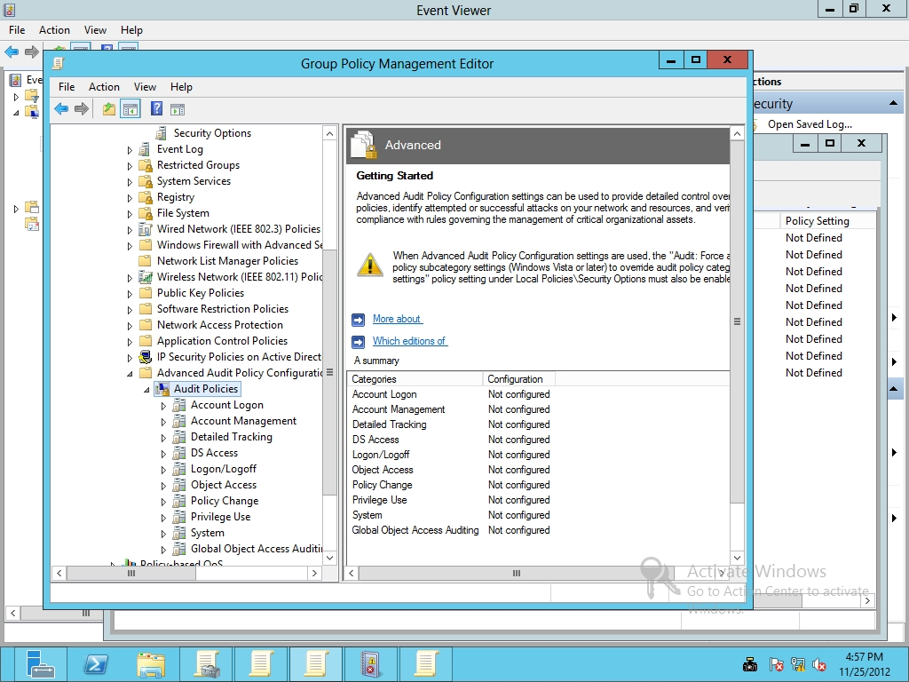

Figure 7-3

Configuring Advanced Audit Policy configuration settings

**3.** Under Audit Policies, double-click Logon/Logoff.

**4.** Double-click Audit Account Lockout. When the Audit Account Lockout Properties dialog box opens, click to select Configure the following audit events, and then select Success. Click OK to close Audit Lockout Properties.

**5.** Configure the following settings:

Audit Logoff Success

Audit Logon Success and Failure

**6.** Take a screen shot of the Group Policy Management Editor window by pressing Alt+Prt Scr and then paste it into your Lab07_worksheet file in the page provided by pressing Ctrl+V.

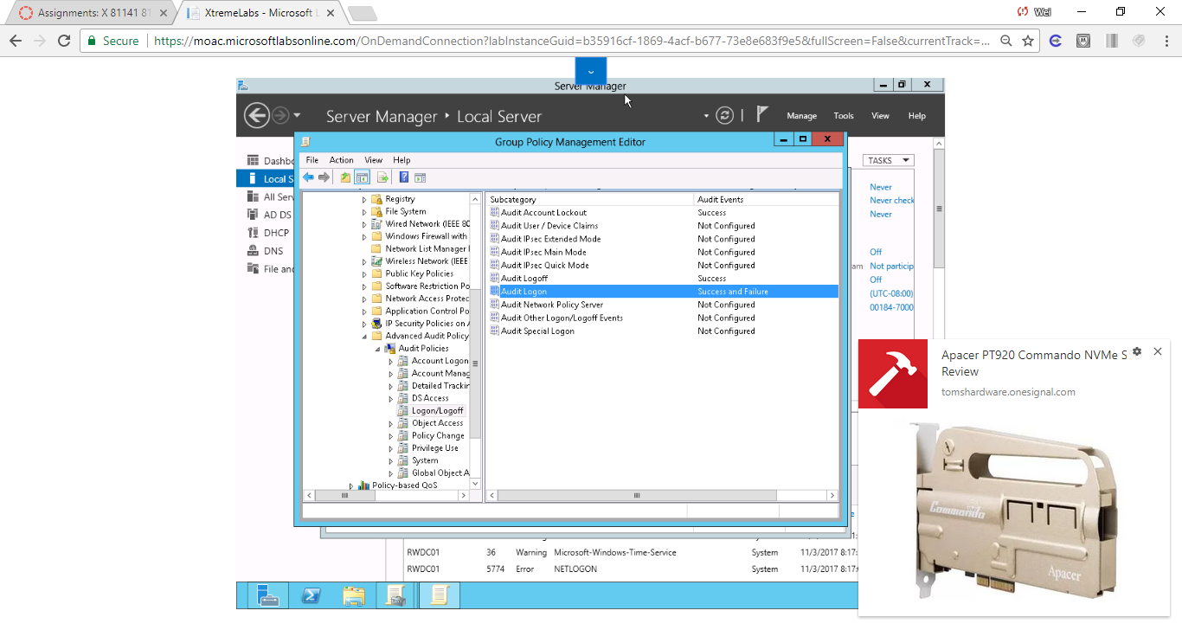

Figure 1 A screen shot of the Group Policy Management Editor window after Step 1- 5

**7.** Under Audit Policies, click Account Management and configure the following settings:

Audit Computer Account Management Success and Failure

Audit Security Group Management Success and Failure

Audit User Account Management Success and Failure

**8.** Under Audit Policies, click Object Access and configure the following settings:

Audit File Share Success and Failure

Audit File System Success and Failure

Audit Registry Success and Failure

Audit SAM Success and Failure

**9.** Click Privilege Use and configure the following settings:

Audit Sensitive Privilege Use Success and Failure

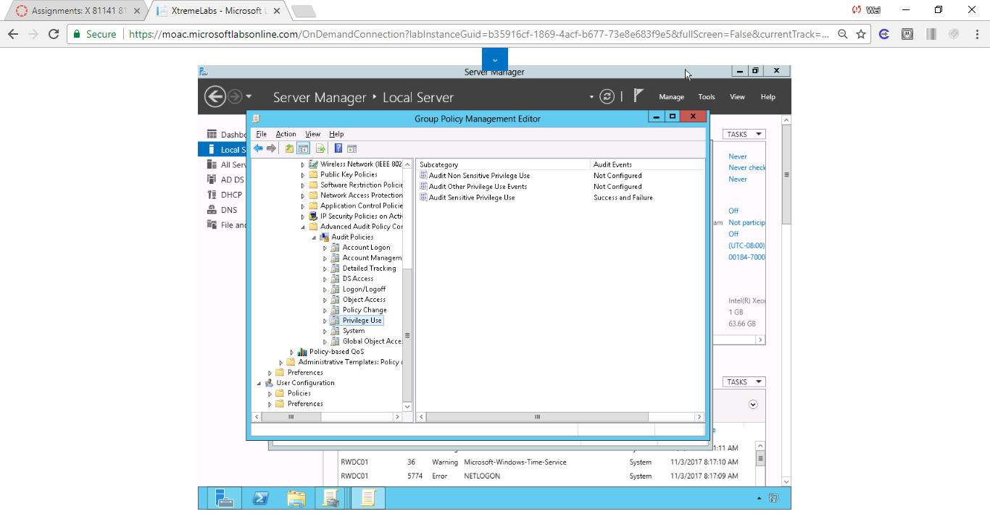

Figure 2 Privilege User Configuration

**10.** Click System and configure the following settings:

Audit Security State Change Success and Failure

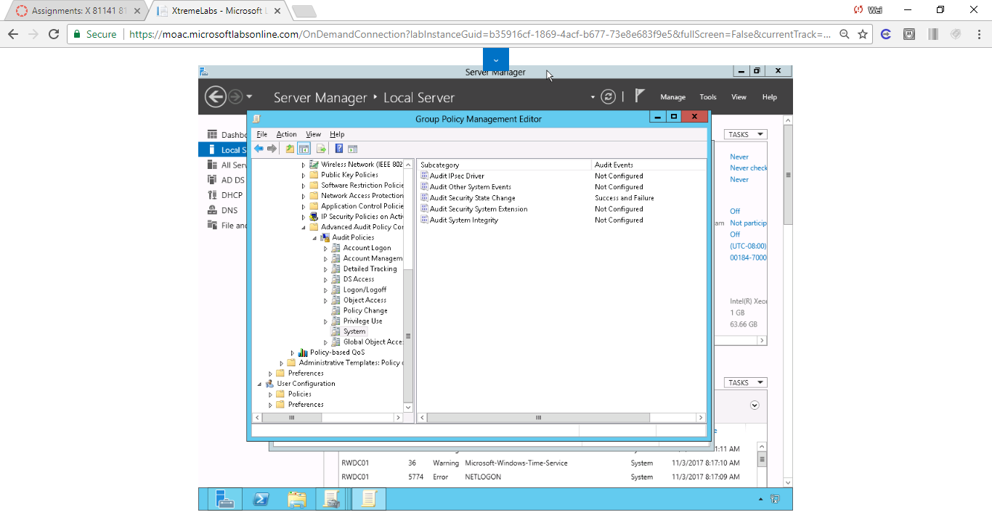

Figure 3 Screenshot of System Configuration

**11.** Close the Group Policy Management Editor.

**12.** Go to Server01, open a Command prompt windows, and execute the gpupdate /force command.

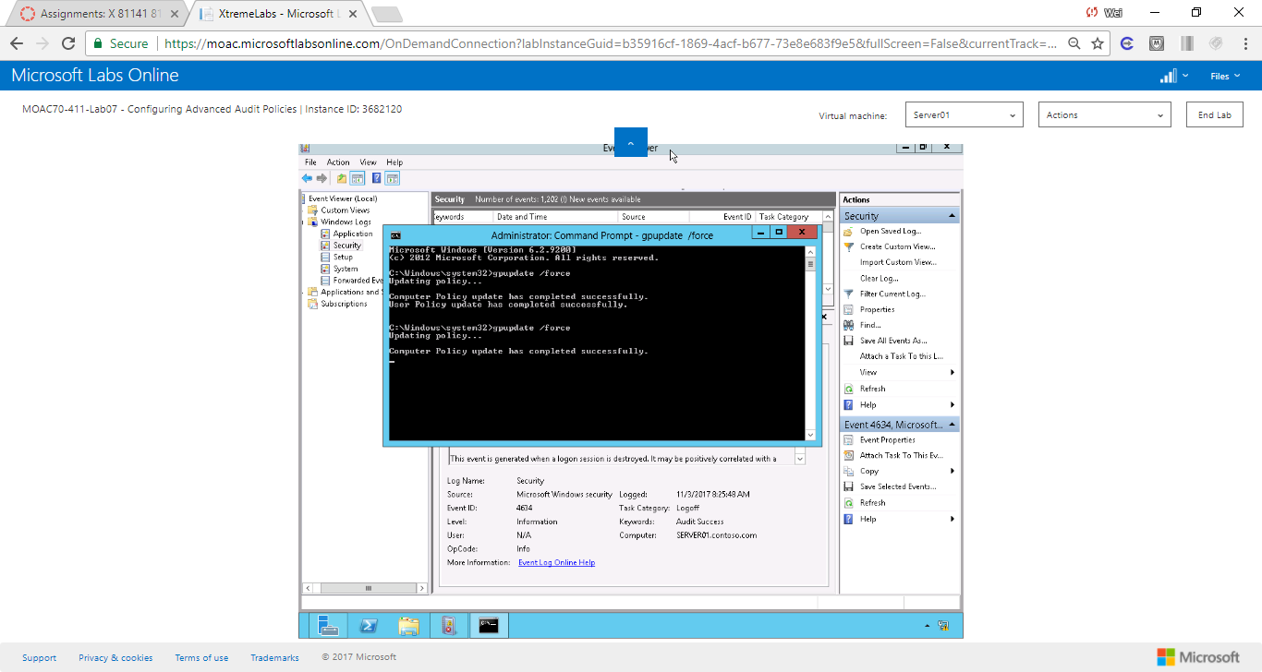

Figure 4 gpupdate command was executed successfully.

**Lab Summary**

During this exercise, I used Advanced Audit Policies to help keep track of who uses and attempts to use my network resources. Advanced auditing have more options to aduit than standard auditing. Advanced auditing settings is located here

*In the Group Policy Management Editor on RWDC01, navigate to Computer Configuration\Policies\Windows Settings\Security Settings\Advanced Audit Policy Configuration*

I can enable auditing of the Registry Under Audit Policies, click Object Access, audit registry.